**SOFTWARE PROJECT TEAM MEMBERS.**

|  |  |  |
| --- | --- | --- |
| ***TITLE*** | ***NAME*** | ***REGISTRATION NO.*** |
| **PROJECT MANAGER** | **KASEMA JAMES LUTEGO** | **21100533350037** |
| **DEVELOPER** | **ISMAIL SAID SEIF** | **21100533350031** |
| **DEVELOPER** | **DAUD EPAPHRAS MWIGAMBA** | **21100533350020** |
| **ANALYSTS MANAGER** | **IRFAN AHMAD BHATTI** | **21100533350010** |
| **PRODUCT DESIGNER** | **NEEMA WILFRED YOHANA** | **21100533350021** |
| **TESTER** | **NEEMA SAYI MAYOMBO** | **21100533350044** |

**Software Design Document: MUST Online Voting Website System (MOVS)**

**Introduction:** The purpose of this software design document is to outline the system architecture and design for a Must online voting website system. This system will allow registered voters to securely and anonymously cast their votes in various elections.

**Project Requirements:**

1. User Registration: The system must allow users to register for an account to access the voting system.
2. Voter Authentication: The system must authenticate voters using a secure login process.
3. Ballot Creation: The system must allow authorized users to create ballots for various elections.
4. Vote Casting: The system must allow registered and authenticated voters to cast their votes for elections.
5. Results Reporting: The system must generate accurate and timely results for elections.

**Architecture:** The system will use a three-tier architecture, with the **presentation tier, application tier** and **data tier.**

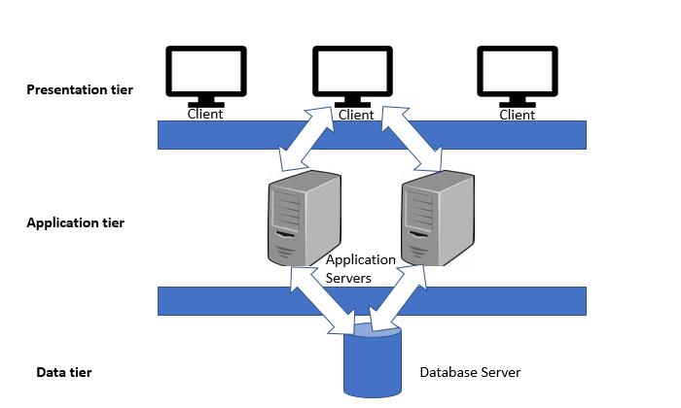

* Presentation Tier: The presentation tier will include the website user interface, which will allow voters to interact with the system.
* Application Tier: The application tier will include the business logic and server-side programming, which will handle user authentication, ballot creation, vote casting, and results reporting.
* Data Tier: The data tier will include the database that stores user account information, ballot data, and election results.

**User Interface:** The website user interface will allow voters to register for an account, authenticate themselves, view available elections, and cast their votes. The user interface will be designed to be simple and intuitive, with clear instructions and error messages.

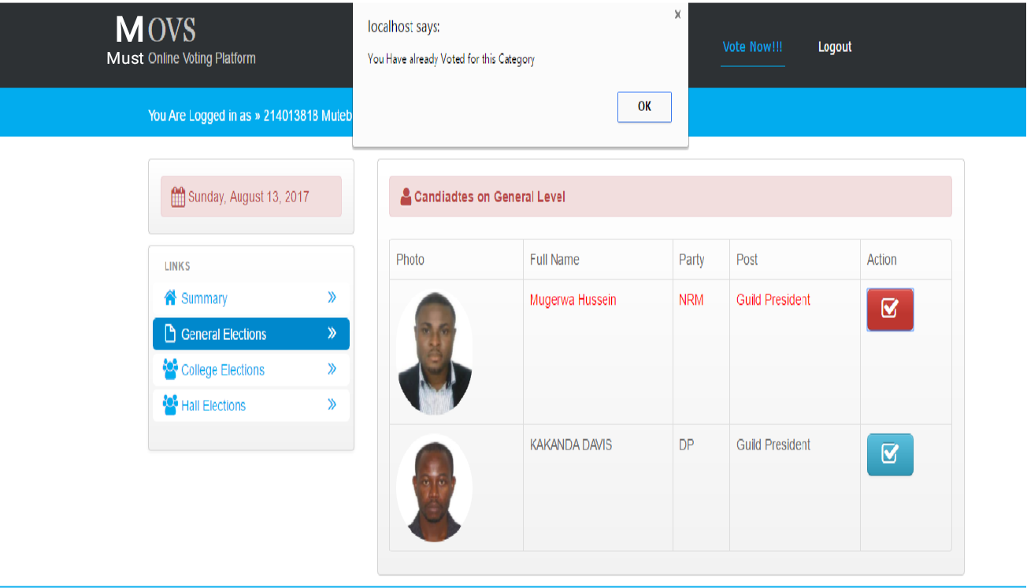

**Data Design:** The system's database will be designed to store user account information, ballot data, and election results. The database schema will include tables for user accounts, ballots, and votes. Th e database will use SQL for data storage and retrieval.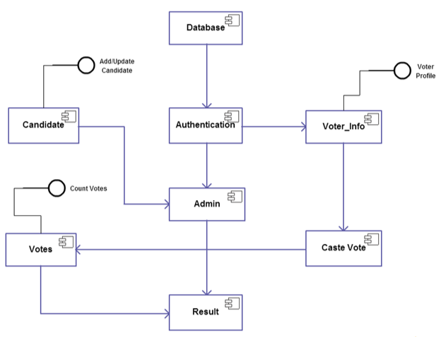

**Algorithms and Logic:** The system will use various algorithms and logic to ensure the security and accuracy of the voting process. These will include:

* User authentication: The system will use strong **encryption algorithms** and **secure hashing methods** to protect user account information and prevent unauthorized access.
* Ballot creation: The system will allow authorized users to create ballots using a user-friendly interface, and will enforce strict validation rules to ensure ballot accuracy and consistency.
* Vote casting: The system will use a secure, anonymous, and auditable voting process to ensure that each voter's ballot is counted accurately.
* Results reporting: The system will generate accurate and timely results for elections using a combination of real-time and batch processing methods.

**Testing:** The system will be tested thoroughly using various testing methods, including unit testing, integration testing, and user acceptance testing. The testing process will ensure that the system is secure, reliable, and easy to use.

**Performance:** The system will be optimized for performance and scalability, with a focus on minimizing response times and maximizing throughput. The system will use caching, load balancing, and other performance optimization techniques to ensure that the website can handle a large number of concurrent users.

**Security:** The system will be designed to be highly secure, with a focus on preventing unauthorized access, protecting user data, and ensuring the integrity of the voting process. The system will use strong encryption algorithms, secure authentication methods, and strict access control measures to ensure that the system is secure from malicious attacks.

**Conclusion:** This software design document outlines the architecture and design for a secure and reliable voting website system. The system will be optimized for performance, scalability, and security, and will provide a simple and intuitive user interface for voters to cast their votes securely and anonymously.